ENE NATURAL SKINCARE LIMITED
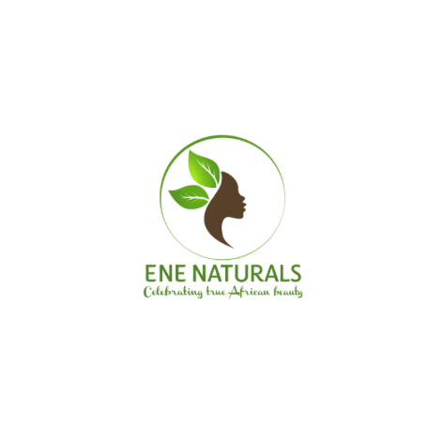

🧪 ESSENTIAL FORMULATION TOOLS FOR BEGINNERS
1. Measuring & Weighing Tools
These ensure accuracy — the foundation of good formulation.
- Digital precision scale (0.01g accuracy)
- Digital kitchen scale (for larger batches)
- Measuring spoons (optional but not ideal for accuracy)
- Beakers (50ml, 100ml, 250ml, 500ml)
- Glass or heat-resistant bowls

2. Mixing & Stirring Tools
To blend oils, waters, emulsions, and gels properly.
- Mini whisk
- Silicone spatulas
- Stainless steel spoons
- Magnetic stirrer (optional but helpful for smooth gels & serums)
- Milk frother / handheld mixer (affordable alternative for emulsions)

3. Heating Tools
For melting butters, heating phases, and emulsification.
- Double boiler setup
(Glass bowl over a pot — simple & safe)
- Portable hot plate or electric stove
- Infrared thermometer or digital probe thermometer

4. pH & Adjustment Tools
pH is critical in skincare safety and stability.
- pH meter (recommended)
- pH indicator strips
- Citric acid solution (for lowering pH)
- Sodium hydroxide or baking soda solution (for raising pH)
- Small pipettes for drop-by-drop adjustments

5. Storage & Containers
For storing raw ingredients and finished products.
- Amber glass bottles
- PET plastic bottles
- Sample jars (10g, 20g)
- Airless pump bottles
- Droppers & pipettes
- Funnels

6. Sanitising & Cleaning Tools
Good Manufacturing Practice (GMP) requires strict hygiene.
- 70% isopropyl alcohol spray
- Paper towels or lint-free cloths
- Disposable gloves
- Face mask (optional but good practice)
- Stainless steel tray for organising tools

7. Documentation Tools
Every formulator must keep detailed records.
- Notebook or formulation journal
- Printed formula sheets
- Pen, highlighters, sticky notes
- Batch production records (BPR)
- Ingredient stock inventory sheet

8. Ingredient Handling Tools
Useful when working with powders, waxes, clays, and extracts.
- Micro measuring spoons (0.1 ml, 0.25 ml, 0.5 ml)
- Small scoops
- Fine mesh sieve (for clays or powders)
- Droppers for essential oils

9. Emulsification Tools
For cream and lotion-making.
- Hand blender / immersion blender
- Mini homogenizer (optional for beginners but gives smoother creams)
- Double boiler (again essential here)
- Heat-resistant beakers for oil/water phases

10. Safety Gear
Never formulate without proper protection.
- Heat-resistant gloves
- Safety goggles
- Lab coat or apron
- Closed footwear

Recommended Starter Kit for Students
- Precision scale
- Two beakers
- Mini whisk
- Silicone spatula
- Thermometer
- 100ml PET bottle
- 50ml amber glass bottle
- pH strips
- Alcohol spray bottle
This is affordable and perfect for beginners.

